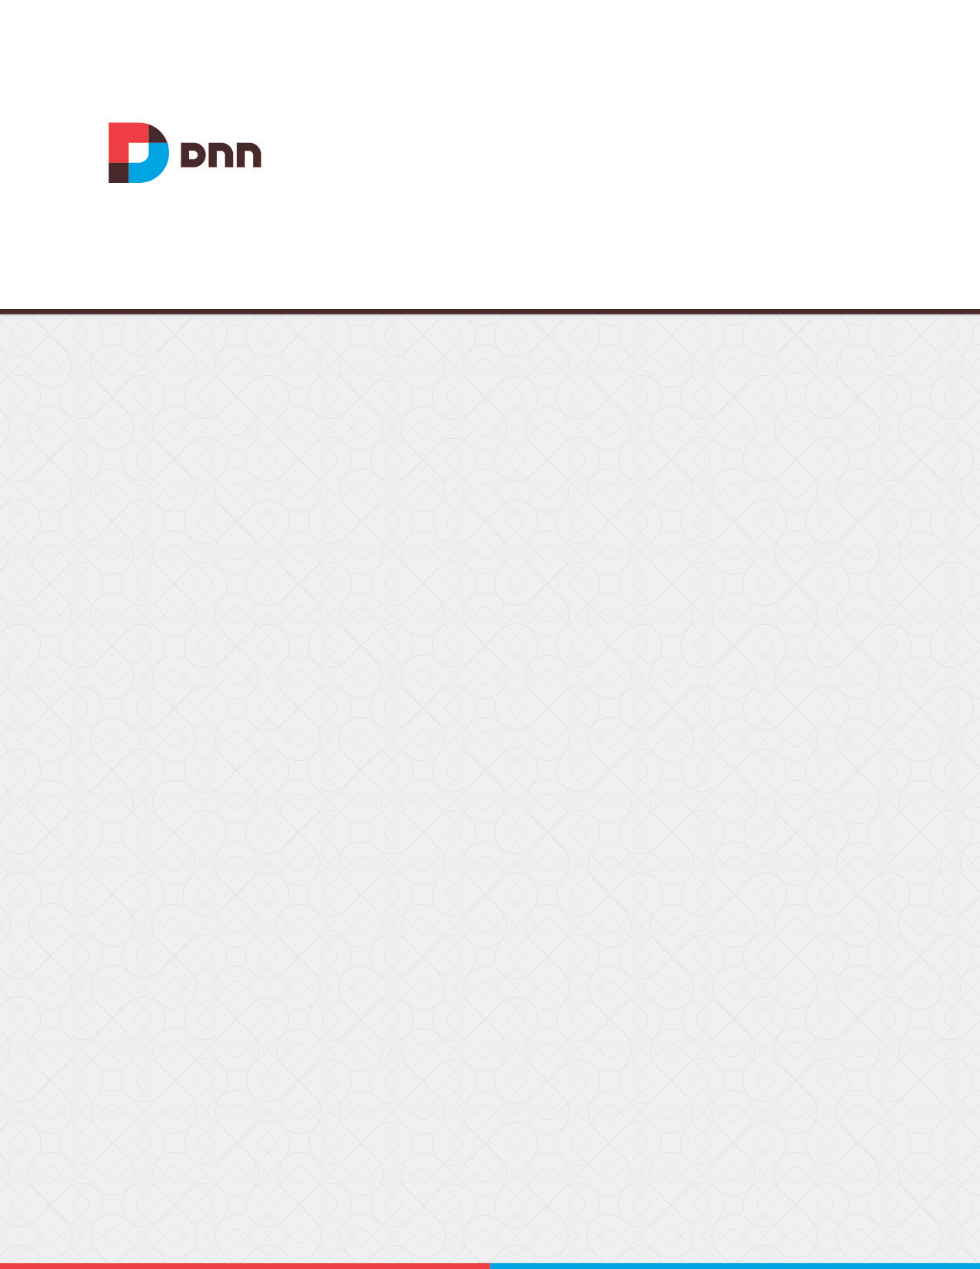

Site Log 07.04.00
User Manual

Contents
Banners Error! Bookmark not defined.
Displaying Banners Error! Bookmark not defined.
Troubleshooting: Image Not Displaying Error! Bookmark not defined.

Site Log
The Admin > Advanced Settings > INCLUDEPICTURE "Dnn.Platform/Documentation/Resources/Images/Icons/SiteLog_16X16_Standard.png" \* MERGEFORMAT \d Site Log page enables users to view twelve statistical reports on site activity. By default the reports display activities for last seven days including today or they can be set to show data for any preferred date range. Any user who has been granted access to view this module can view reports. Super Users can enable the Site Log and restrict the number of days log history is kept for.
Note: When the Site Log is enabled, the Host > Schedule page will display the "Purge Site Log" tasks which deletes all Site Log data for days outside of the site log history. E.g. this task will delete records older than 30 days when Site Log history is set to 30 days.
INCLUDEPICTURE "Dnn.Platform/Documentation/Resources/Images/Admin/SiteLog/SiteLog_650x238.png" \* MERGEFORMAT \d

Enabling the Site Log
The Site Log is disabled by default and must be enabled and configured by a Super User before it can be used to generate reports.

Reports

Affiliate Referrals
The Affiliate Referrals report tracks referrals from affiliates that include an affiliate ID = number in the URL to the site. This report displays the Affiliate Id number; the number of requests associated with this affiliate; and the date and time of the last referral.

Detailed Site Log
The Detailed Site Log report displays a detailed log of all site activity for all site users, including Administrators and Super Users. This report displays the date and time of each visit; the username of authenticated users; the previous website that the user visited prior to this session; the web browser; the host address of the user; and the name of the page they visited.
INCLUDEPICTURE "Dnn.Platform/Documentation/Resources/Images/Admin/SiteLog/SiteLog_DetailedSiteLog_650x393.png" \* MERGEFORMAT \d

Page Popularity
The Page Popularity report displays a summary list of the most visited pages. This report details the name of the page being visited, the number of times the page was visited; and the last time the page was visited.
INCLUDEPICTURE "Dnn.Platform/Documentation/Resources/Images/Admin/SiteLog/SiteLog_PagePopularity_650x363.png" \* MERGEFORMAT \d

Page Views by Day
The Page Views by Day report provides a summary list of the number of visitors and users who viewed the site for the selected day range. This report displays the date of the visit; and the number of views, visitors and registered user visits for the day.
INCLUDEPICTURE "Dnn.Platform/Documentation/Resources/Images/Admin/SiteLog/SiteLog_PageViewsByDay_650x256.png" \* MERGEFORMAT \d

Page Views by Day of Week
The Page Views by Day of Week report displays a summary list of the number of visitors and users who viewed the site during the selected day range. This report details the day of the week, the number of views for the day; the number of all visitors for the day; and the number of registered user visits for the day.
INCLUDEPICTURE "Dnn.Platform/Documentation/Resources/Images/Admin/SiteLog/SiteLog_PageViewsByDayOfWeek_650x256.png" \* MERGEFORMAT \d

Page Views by Hour
The Page Views by Hour report provides a summary list of the number of visitors and users who viewed the site each hour for the selected day range. This report displays the hour that the visitor first came to the site (based on a 24 hour clock); and the number of views, visitors and registered user visits for the hour.
INCLUDEPICTURE "Dnn.Platform/Documentation/Resources/Images/Admin/SiteLog/SiteLog_PageViewsByHour_650x332.png" \* MERGEFORMAT \d

Page Views by Month
The Page Views by Month report displays the total number of visitors and users who viewed the site each month for the selected range of months. This report displays the number of the current calendar month (e.g. 1 = January); and the number of views, visitors and registered user visits for the month.
INCLUDEPICTURE "Dnn.Platform/Documentation/Resources/Images/Admin/SiteLog/SiteLog_PageViewsByMonth_650x315.png" \* MERGEFORMAT \d

Site Referrals
The Site Referrals report displays a summary list of the website or search engine that visitors were on prior to visiting the site. This report displays the URL of the referring website; the number of requests; and the date and time of the last request.
INCLUDEPICTURE "Dnn.Platform/Documentation/Resources/Images/Admin/SiteLog/SiteLog_SiteReferrals1_650x361.png" \* MERGEFORMAT \d

User Agents
The User Agents report displays a summary list of the search engine bots and Web browsers that visitors were using when they visited the site. This report display the name of the search engine or web browser used, the number of requests from the agent and the date and time of the last request.
INCLUDEPICTURE "Dnn.Platform/Documentation/Resources/Images/Admin/SiteLog/SiteLog_UserAgents_650x333.png" \* MERGEFORMAT \d

User Frequency
The User Frequency report displays a list of registered users and shows how many pages they have visited as well as the time of their last visit. This report displays the user's first and last name; the total number of page requests by this user; and the date and time of the last request.
INCLUDEPICTURE "Dnn.Platform/Documentation/Resources/Images/Admin/SiteLog/SiteLog_UserFrequency_650x445.png" \* MERGEFORMAT \d

User Registrations by Country
The User Registrations by Country report displays the number of new registered users for each country for the selected date range. This report displays the user's first and last name; their user name; and the country selected by a user on their user profile.
INCLUDEPICTURE "Dnn.Platform/Documentation/Resources/Images/Admin/SiteLog/SiteLog_UserRegistrationByCountry_650x517.png" \* MERGEFORMAT \d

User Registrations by Date
The User Registrations by Date report displays the number of new registered users for each date within the selected date range. This report displays the user's first and last name; their user name; and the date and time when they registered.
INCLUDEPICTURE "Dnn.Platform/Documentation/Resources/Images/Admin/SiteLog/SiteLog_UserRegistrationByDate_650x437.png" \* MERGEFORMAT \d


